11 – ReactJS-HOL
Multi-Method Invocation Execution Pipeline
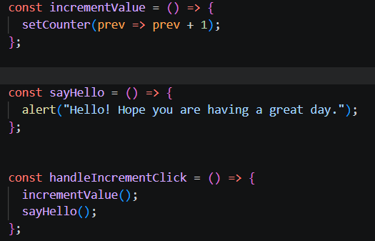
Inline Parameterized Message Function Binding
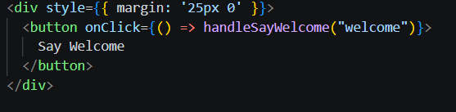
Synthetic Event Tracking Implementation
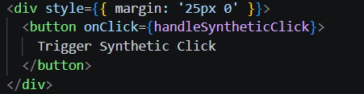
Form Submission & State-driven Currency Calculation Engine
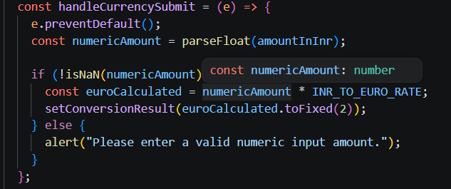
Code Output:
